Batch: A1 Roll No.: 16010123012

Experiment / Assignment / Tutorial No.: 05

Title: Implementation of DBScan clustering Algorithm

Aim: To understand & implement DBScan clustering Algorithm using python.
Expected Outcome of Experiment:
CO4: Apply clustering and dimension reduction algorithms to analyse and interpret data patterns effectively.
Books/ Journals/ Websites referred:
1. “Machine Learning”, Tom M. Mitchell, McGraw Hill, 2017.
2.https://www.geeksforgeeks.org/machine-learning/decision-tree-introduction-example/
3. https://medium.com/@abhishekjainindore24/all-about-decision-trees-80ea55e37fef

Theory of DBScan Clustering Algorithm:

DBSCAN is a density-based clustering algorithm that groups data points that are closely packed together and marks outliers as noise based on their density in the feature space. It identifies clusters as dense regions in the data space separated by areas of lower density. Unlike K-Means or hierarchical clustering which assumes clusters are compact and spherical, DBSCAN perform well in handling real-world data irregularities such as:
- Arbitrary-Shaped Clusters: Clusters can take any shape not just circular or convex.
- Noise and Outliers: It effectively identifies and handles noise points without assigning them to any cluster.

Key Parameters in DBSCAN:
1. eps: This defines the radius of the neighborhood around a data point. If the distance between two points is less than or equal to eps they are considered neighbors. A common method to determine eps is by analyzing the k-distance graph. Choosing the right eps is important:
- If eps is too small most points will be classified as noise.
- If eps is too large clusters may merge and the algorithm may fail to distinguish between them.
2. MinPts: This is the minimum number of points required within the eps radius to form a dense region. A general rule of thumb is to set MinPts >= D+1 where D is the number of dimensions in the dataset.
DBSCAN works by categorizing data points into three types:
- Core points which have a sufficient number of neighbors within a specified radius (epsilon)
- Border points which are near core points but lack enough neighbors to be core points themselves
- Noise points which do not belong to any cluster.

Steps in the DBSCAN Algorithm:
- Identify Core Points: For each point in the dataset count the number of points within its eps neighborhood. If the count meets or exceeds MinPts mark the point as a core point.
- Form Clusters: For each core point that is not already assigned to a cluster create a new cluster. Recursively find all density-connected points i.e points within the eps radius of the core point and add them to the cluster.
- Density Connectivity: Two points a and b are density-connected if there exists a chain of points where each point is within the eps radius of the next and at least one point in the chain is a core point. This chaining process ensures that all points in a cluster are connected through a series of dense regions.
- Label Noise Points: After processing all points any point that does not belong to a cluster is labeled as noise.

Evaluation Metrics For DBSCAN Algorithm In Machine Learning :
Use the Silhouette score and Adjusted rand score for evaluating clustering algorithms.
- Silhouette's score is in the range of -1 to 1. A score near 1 denotes the best meaning that the data point i is very compact within the cluster to which it belongs and far away from the other clusters. The worst value is -1. Values near 0 denote overlapping clusters.
- Absolute Rand Score is in the range of 0 to 1. More than 0.9 denotes excellent cluster recovery and above 0.8 is a good recovery. Less than 0.5 is considered to be poor recovery.

Problem Definition:
Apply DBScan Clustering algorithm and evaluate its performance using different metrics.
Details of data set used: https://drive.google.com/file/d/13BRlRCPx5o5r2aygKW7jK_U5O1sFKw9j/view
API/Function used:
read_csv(), StandardScaler(), DBSCAN(), KMeans()
fit_predict(), silhouette_score(), adjusted_rand_score()
scatter(), show()

Results:
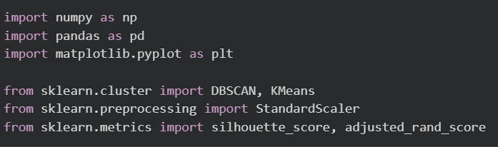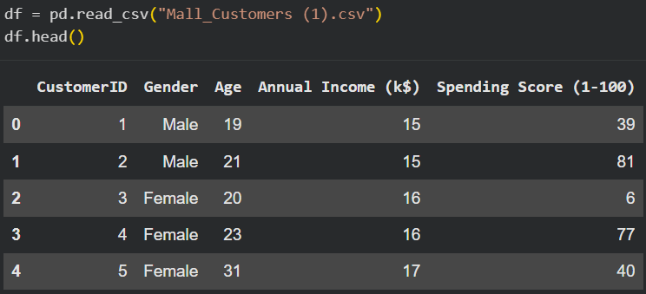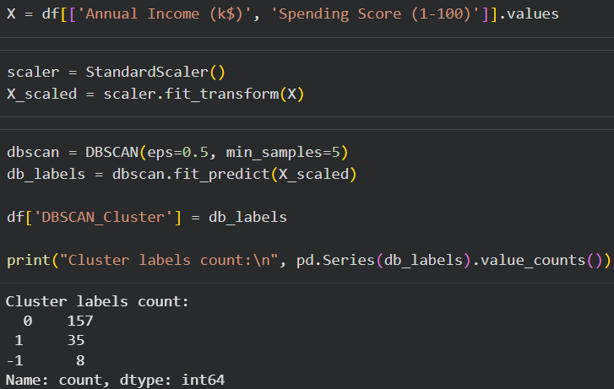
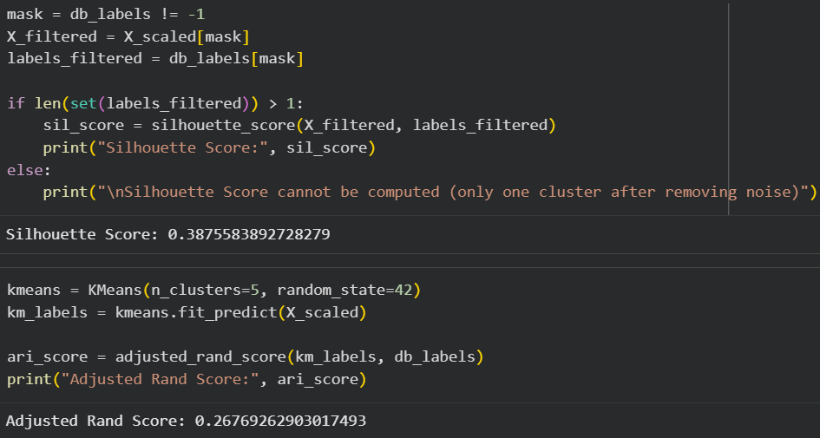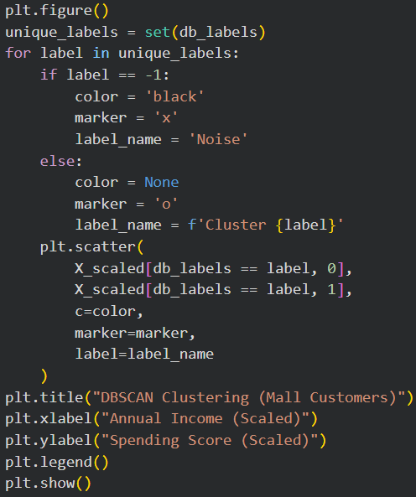
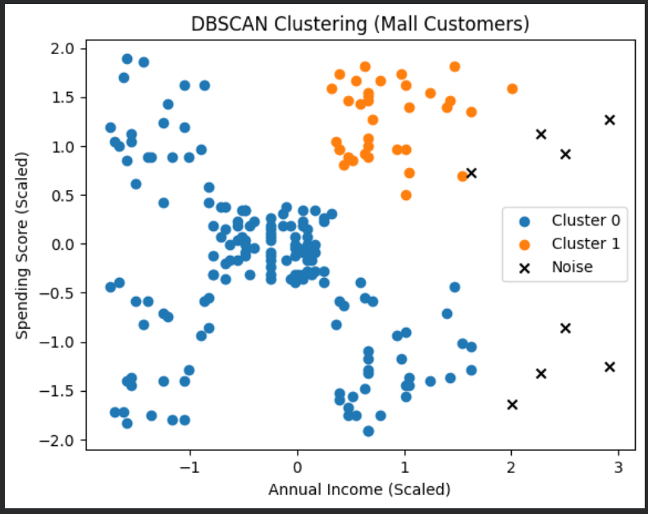
Conclusion:
In this experiment, the DBSCAN clustering algorithm was implemented to identify clusters based on data density. Unlike traditional clustering methods, DBSCAN successfully detected arbitrarily shaped clusters and effectively identified noise points. By tuning parameters such as eps and MinPts, meaningful clusters were formed. The performance was evaluated using metrics like Silhouette Score and Adjusted Rand Index, demonstrating DBSCAN’s effectiveness in handling real-world datasets with noise and irregular cluster shapes.

Post Lab
- List and explain the various distance metrics used to measure the similarity.
Distance metrics are used to measure how similar or different two data points are. Common metrics include:
- Euclidean Distance
Measures straight-line distance between two points.
Used for continuous numerical data.
Example: Distance between (x₁, y₁) and (x₂, y₂)
- Manhattan Distance
Measures distance along grid paths (sum of absolute differences).
Useful when movement is restricted to axes.
- Minkowski Distance
Generalized form of Euclidean and Manhattan distance.
Controlled by parameter p.
- Cosine Similarity
Measures angle between two vectors instead of distance.
Useful for text and high-dimensional data.
- Hamming Distance
Counts number of positions where values differ.
Used for categorical or binary data.
- Mahalanobis Distance
Considers correlation between variables.
Useful for multivariate data analysis.
- Evaluate any two other Evaluation Indexes for the evaluation of clustering algorithms.
Apart from Silhouette Score and Adjusted Rand Index, other evaluation metrics include:
- Davies-Bouldin Index (DBI)
Measures average similarity between clusters.
Lower value indicates better clustering (well-separated clusters).
- Calinski-Harabasz Index (CHI)
Measures ratio of between-cluster dispersion to within-cluster dispersion.
Higher value indicates better-defined clusters.
- Inertia (Within-Cluster Sum of Squares)
Measures compactness of clusters.
Lower value indicates tighter clusters (used in K-Means).
- Dunn Index
Measures ratio between minimum inter-cluster distance and maximum intra-cluster distance.
Higher value indicates better clustering.

